The inventor of the relational model Edgar Codd proposed the theory of normalization with the introduction of First Normal Form, and he continued to extend theory with Second and Third Normal Form. Later he joined with Raymond F. Boyce to develop the theory of Boyce-Codd Normal Form.

Theory of Data Normalization in SQL is still being developed further. For example, there are discussions even on 6th Normal Form. **However, in most practical applications, normalization achieves its best in 3rd Normal Form**. The evolution of Normalization theories is illustrated below-



**Database Normalization Examples -**

Assume a video library maintains a database of movies rented out. Without any normalization, all information is stored in one table as shown below.

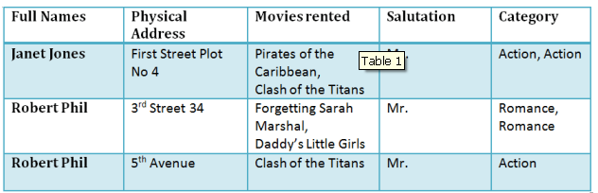

Here you see **Movies Rented column has multiple values**.

**Database Normal Forms**

Now let's move into 1st Normal Forms

## ****1NF (First Normal Form) Rules****

* Each table cell should contain a single value.
* Each record needs to be unique.

The above table in 1NF-

### 1NF Example

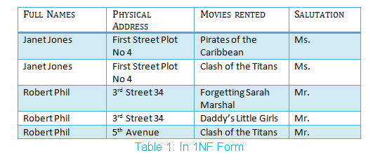

Before we proceed let's understand a few things --

## What is a KEY?

A KEY is a value used to identify a record in a table uniquely. A KEY could be a single column or combination of multiple columns

Note: Columns in a table that are NOT used to identify a record uniquely are called non-key columns.

What is a Primary Key?

|  |  |
| --- | --- |
|  | A primary is a single column value used to identify a database record uniquely.  It has following attributes   * A primary key cannot be NULL * A primary key value must be unique * The primary key values cannot be changed * The primary key must be given a value when a new record is inserted. |

## What is Composite Key?

A composite key is a primary key composed of multiple columns used to identify a record uniquely

In our database, we have two people with the same name Robert Phil, but they live in different places.

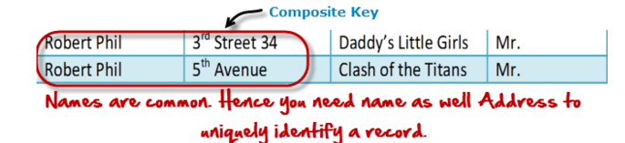

Hence, we require both Full Name and Address to identify a record uniquely. That is a composite key.

Let's move into second normal form 2NF

## 2NF (Second Normal Form) Rules

* Rule 1- Be in 1NF
* Rule 2- Single Column Primary Key

It is clear that we can't move forward to make our simple database in 2ndNormalization form unless we partition the table above.

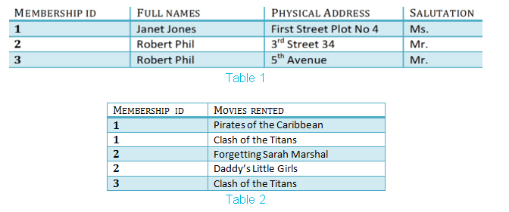

We have divided our 1NF table into two tables viz. Table 1 and Table2. Table 1 contains member information. Table 2 contains information on movies rented.

We have introduced a new column called Membership_id which is the primary key for table 1. Records can be uniquely identified in Table 1 using membership id.

## Database - Foreign Key

In Table 2, Membership ID is the Foreign Key.

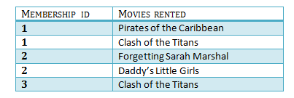

|  |  |
| --- | --- |
|  | Foreign Key references the primary key of another Table! It helps connect your Tables   * A foreign key can have a different name from its primary key * It ensures rows in one table have corresponding rows in another * Unlike the Primary key, they do not have to be unique. Most often they aren't * Foreign keys can be null even though primary keys can not |

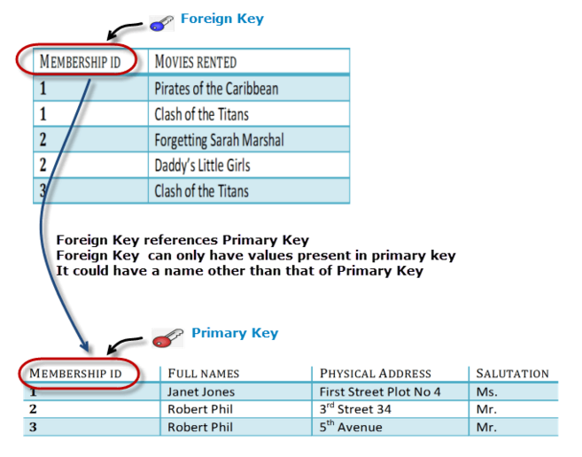

Why do you need a foreign key?

Suppose an idiot inserts a record in Table B such as

You will only be able to insert values into your foreign key that exist in the unique key in the parent table. This helps in referential integrity.

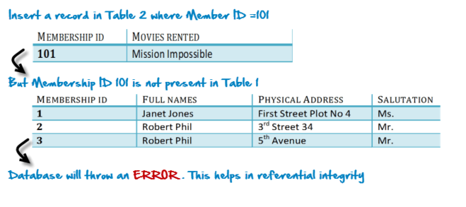

The above problem can be overcome by declaring membership id from Table2 as foreign key of membership id from Table1

Now, if somebody tries to insert a value in the membership id field that does not exist in the parent table, an error will be shown!

## What are transitive functional dependencies?

A transitive functional dependency is when changing a non-key column, might cause any of the other non-key columns to change

Consider the table 1. Changing the non-key column Full Name may change Salutation.

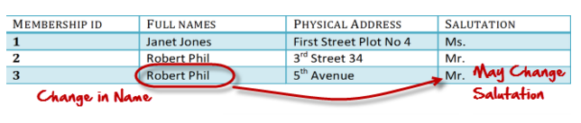

Let's move into 3NF

## 3NF (Third Normal Form) Rules

* Rule 1- Be in 2NF
* Rule 2- Has no transitive functional dependencies

To move our 2NF table into 3NF, we again need to again divide our table.

3NF Example:

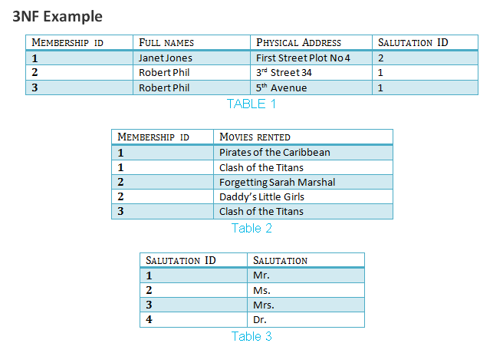

**Boyce-Codd Normal Form (BCNF)**

Even when a database is in 3rd Normal Form, still there would be anomalies resulted if it has more than one Candidate Key.

Sometimes is BCNF is also referred as 3.5 Normal Form.

**4NF (Fourth Normal Form) Rules**

If no database table instance contains two or more, independent and multivalued data describing the relevant entity, then it is in 4th Normal Form.

**5NF (Fifth Normal Form) Rules**

A table is in 5th Normal Form only if it is in 4NF and it cannot be decomposed into any number of smaller tables without loss of data.

**6NF (Sixth Normal Form) Proposed**

6th Normal Form is not standardized, yet however, it is being discussed by database experts for some time. Hopefully, we would have a clear & standardized definition for 6th Normal Form in the near future...

That's all to Normalization!!!

**Summary**

* Database designing is critical to the successful implementation of a database management system that meets the data requirements of an enterprise system.
* Normalization helps produce database systems that are cost-effective and have better security models.
* Functional dependencies are a very important component of the normalize data process
* Most database systems are normalized database up to the third normal forms.
* A primary key uniquely identifies are record in a Table and cannot be null
* A foreign key helps connect table and references a primary key

[**https://www.guru99.com/database-normalization.html**](https://www.guru99.com/database-normalization.html)